**Standard Operating Procedure for 1D Simulation model**

Author: Eric (Xianbin) Cheng, Minho Kim

# Synopsis

This is an instruction for downloading and running the ILSI simulation model (continuous mode) in R Markdown.

# Stable Versions

|  |  |  |
| --- | --- | --- |
| Version | Date | Brief Description |
| 1.0 | 2/1/2019 | * Continuous mode and discrete mode are inseparable |
| 2.0.1 | 4/25/2019 | * Continuous mode is separated from discrete mode * Decay functions include “exp”, “norm”, “unif” |
| 2.1.2 | 5/9/2019 | * Contamination types include point-source and area-based |
| 2.1.5 | 5/13/2019 | * Able to visualize binary results for enrichment |
| 2.1.7 | 6/12/2019 | * Able to do 2D STRS * Fix the bug of binomial process for enrichment |
| 2.2.5 | 7/5/2019 | * Fix the contamination point location with “seed” |
| 2.3.1 | 7/12/2019 | * Update the discrete mode with “seed” and new iteration structure |
| 2.4.1 | 7/18/2019 | * Add kernel grinding step into the discrete mode |
| 3.0 | 7/27/2021 | * 2D continuous model adapted to 1D simulation by changing parameters |
| 3.1.0 | 12/8/2021 | * Functions added for 1D simulation |

# Downloading

To run the simulation model, you need to download the correct version of R scripts and Markdown files. We will show the procedure of downloading model version 3.1.0 as an example. Then just follow the instruction below, except for step 2.2 where you have to use the date you chose.

1. Open GitHub page
   1. <https://github.com/foodsafetylab/PIF_Kim>
2. Find the code for ILSI model version 3.1.0
   1. Click the button for “code”.

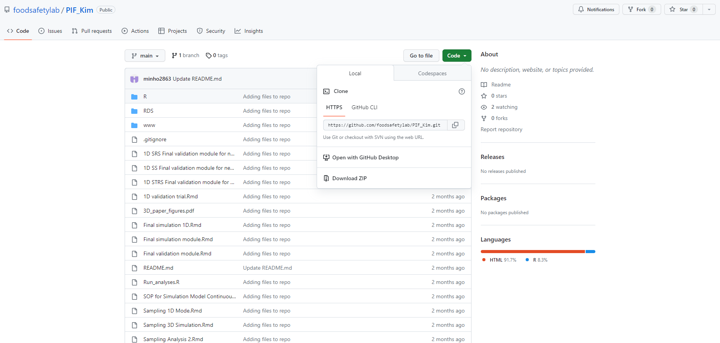

* 1. Download all files with ZIP

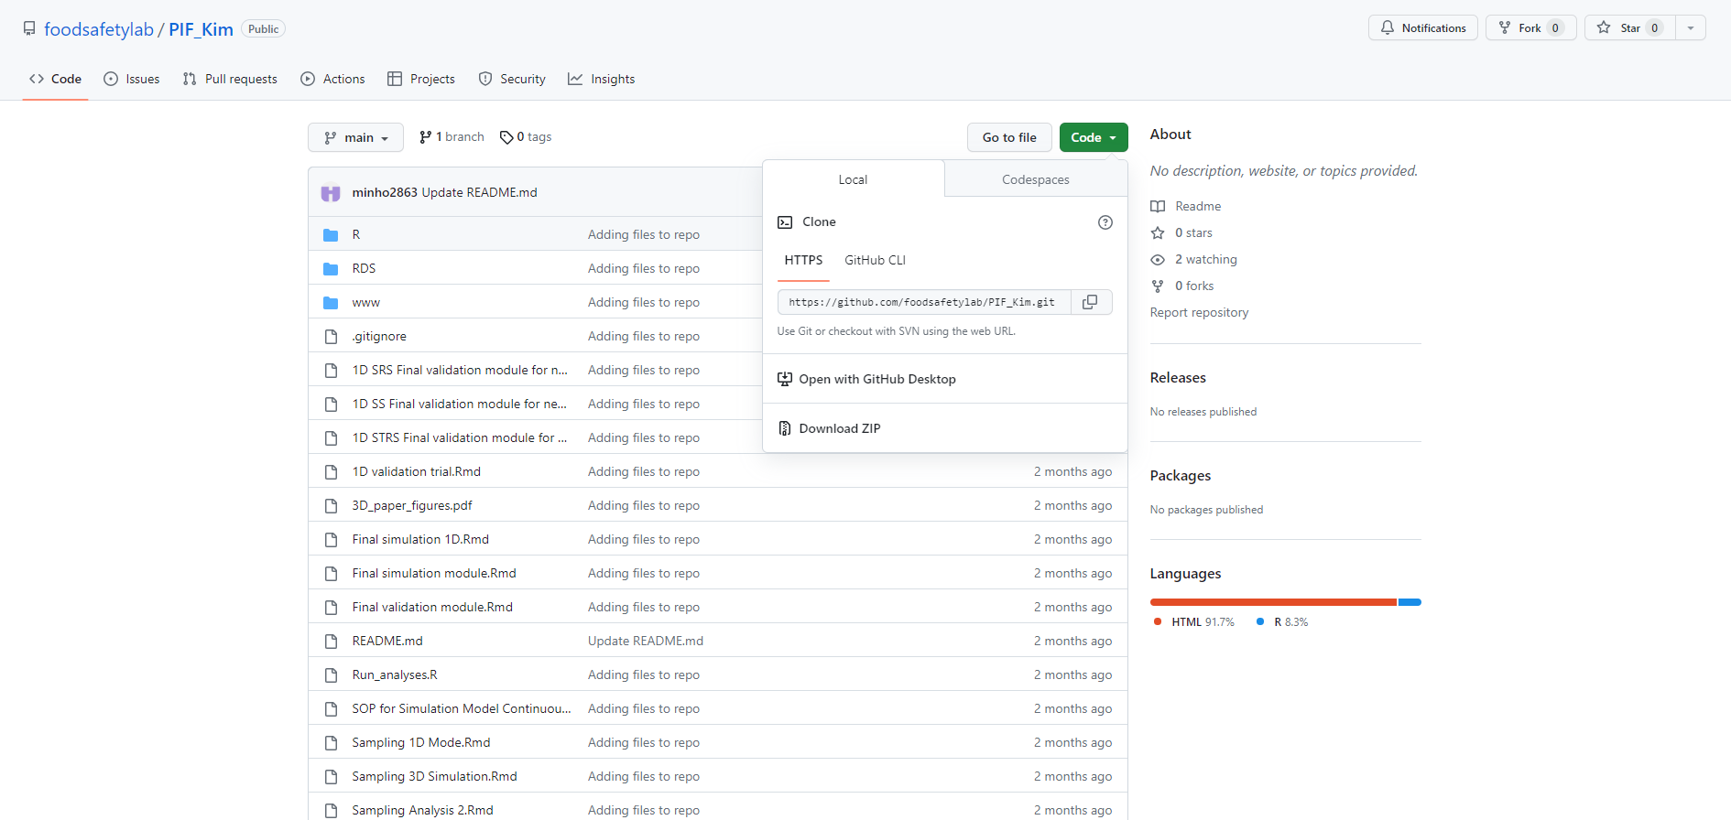

1. Extract everything from the ZIP file and put them in a new folder.

# Installation

1. Installation of R and R Studio
   1. Install R first, then R Studio
2. Installation of R packages
   1. Open the R script **Sampling_libraries.R**
   2. Install *ALL* the packages listed in this script.
      1. Option 1:
         1. Go to “Tools” 🡪 “Install Packages” 🡪 type in each package’s name
      2. Option 2:
         1. Navigate to the console.
         2. Use install.packages(…) to install the packages.
            1. For example: install.packages(“tidyverse”), …

# Model Running

1. Open the Markdown file **Final 1D simulation model.Rmd.**
2. Knit the Markdown file into an HTML file.
3. Open the HTML file you just knitted and read the instruction inside.
4. Adjust input parameters.